Data definition

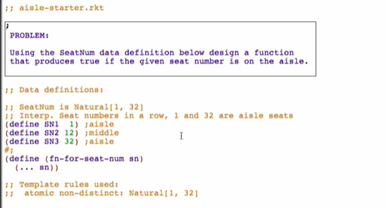

Function Definition

**Signature, Purpose, and Stub**

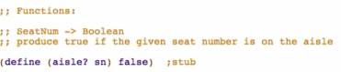

**Examples**

Go to design recipe and under Intervals: Guidance on Data Examples and Function Example/Tests

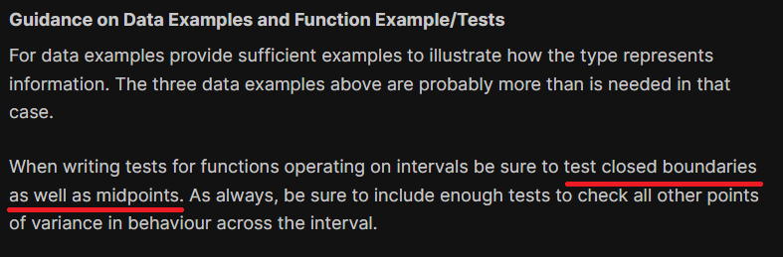

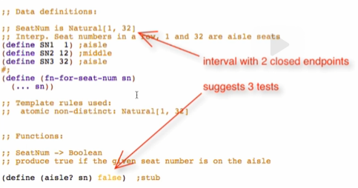

* Start, middle (not necessarily midpt), end



**Template**

Comment out stub and use template from Data definition

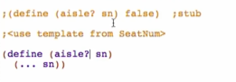

**Code Body**

Copy template and refactor



Overview:

